# Laboratory Work 1: Relational Model, Keys, ER Modeling & Normalization

---

## Part 1: Key Identification Exercises

### Task 1.1: Superkey and Candidate Key Analysis

#### Relation A: Employee
Employee (EmpID, SSN, Email, Phone, Name, Department, Salary)

1. 6 Different Superkeys:
* {EmpID}
* {SSN}
* {Email}
* {EmpID, Name}
* {SSN, Phone}
* {Email, Department, Salary}

2. All Candidate Keys:
* {EmpID}
* {SSN}
* {Email}

3. Primary Key Choice:
* Chosen PK: {EmpID}
* Justification: EmpID is a surrogate numeric key that is short, stable, never changes, and has no privacy sensitivity compared to SSN or Email.

4. Can two employees have the same phone number?
* Answer: Yes, based on the schema and data provided, Phone is neither a primary key nor a candidate key. In real-world scenarios, two employees might share a work phone number or a corporate department extension.

---

Relation B: Course Registration
Registration (StudentID, CourseCode, Section, Semester, Year, Grade, Credits)
- Minimum attributes needed for the Primary Key:
  - {StudentID, CourseCode, Section, Semester, Year}
- Explanation of necessity:
  - StudentID: Identifies which student is registering.
  - CourseCode: Identifies the specific course.
  - Section: Identifies the specific section of the course.
  - Semester & Year: Identify the academic term and allow a student to retake the same course in a different semester or year.
- Additional Candidate Keys:
  - No additional candidate keys can be guaranteed from the given business rules.
  - The combination {StudentID, CourseCode, Section, Semester, Year} is the minimum key that satisfies the stated rule that a student cannot register for the same course section in the same semester.

---

### Task 1.2: Foreign Key Design

Foreign Key Relationships:
* Student(AdvisorID) -> Professor(ProfID)
* Department(ChairID) -> Professor(ProfID)
* Course(DepartmentCode) -> Department(DeptCode)
* Enrollment(StudentID) -> Student(StudentID)
* Enrollment(CourseID) -> Course(CourseID)

---

## Part 2: ER Diagram Construction

### Task 2.1: Hospital Management System

1. Entities:
* Strong Entities: Patient, Doctor, Department
* Weak Entity: Hospital Room (discriminator: RoomNumber, identifying strong entity: Department)
* Associative / Complex Entities: Appointment, Prescription

2. Attribute Classification:
* Patient: PatientID (Simple, Primary Key), Name (Simple/Composite), Birthdate (Simple), Address (Composite: Street, City, State, Zip), Phone (Multi-valued), InsuranceInfo (Simple)
* Doctor: DoctorID (Simple, Primary Key), Name (Simple), Specialization (Multi-valued), Phone (Simple), OfficeLocation (Simple)
* Department: DeptCode (Simple, Primary Key), DeptName (Simple), Location (Simple)
* Hospital Room: RoomNumber (Partial key/discriminator)
* Appointment: AppointmentID (PK), DateTime, Purpose, Notes
* Prescription: PrescriptionID (PK), Dosage, Instructions, Medication

3. Relationships & Cardinalities:
* Doctor works in Department -> N:1
* Department contains Hospital Room -> 1:N (Identifying relationship)
* Patient schedules Appointment -> 1:N
* Doctor conducts Appointment -> 1:N
* Doctor issues Prescription -> 1:N
* Patient receives Prescription -> 1:N

[ER DIAGRAM FOR TASK 2.1]
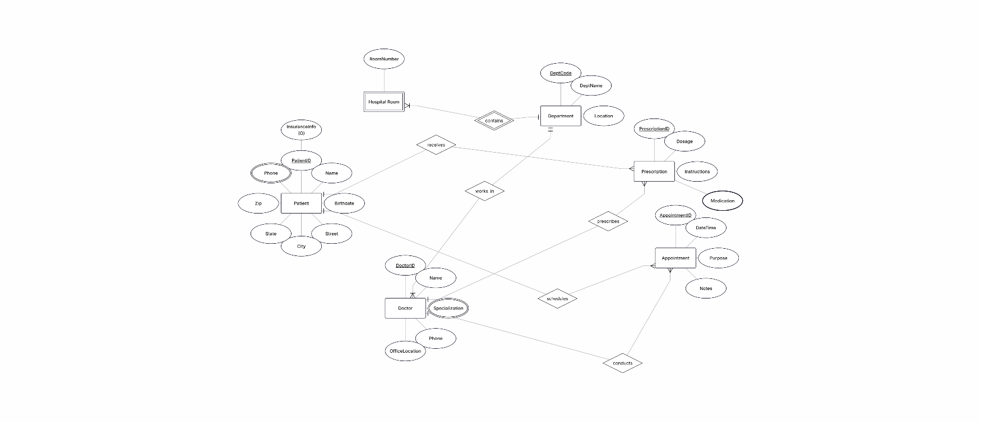
---

### Task 2.2: E-commerce Platform

1. Weak Entity Identification:
* Weak Entity: Order Item
* Justification: An Order Item cannot exist independently without a parent Order. Its primary key is composite, formed by combining OrderID (owner key) and ProductID.

2. Many-to-Many Relationship with Attributes:
* Relationship between Order and Product is M:N.
* Resolved using the associative entity / relationship table Order Item, which carries specific attributes: Quantity and PriceAtTimeOfOrder.

[ ER DIAGRAM FOR TASK 2.2]
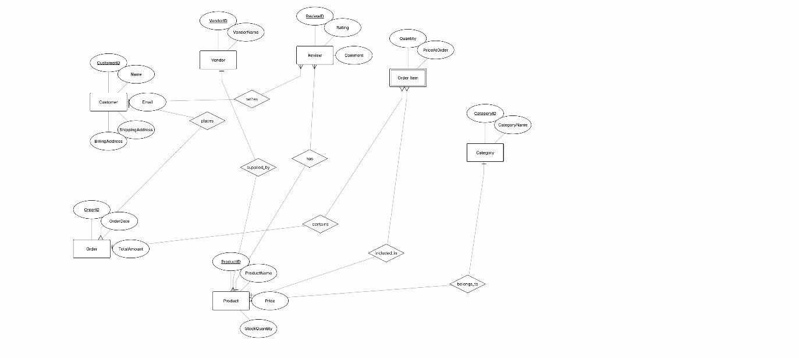
---

## Part 4: Normalization Workshop

### Task 4.1: Denormalized Table Analysis

StudentProject (StudentID, StudentName, StudentMajor, ProjectID, ProjectTitle, ProjectType, SupervisorID, SupervisorName, SupervisorDept, Role, HoursWorked, StartDate, EndDate)

1. Functional Dependencies (FDs):
* FD1: StudentID -> StudentName, StudentMajor
* FD2: ProjectID -> ProjectTitle, ProjectType, SupervisorID, StartDate, EndDate
* FD3: SupervisorID -> SupervisorName, SupervisorDept
* FD4: {StudentID, ProjectID} -> Role, HoursWorked

2. Anomalies and Redundancy:
* Redundancy: SupervisorName and SupervisorDept are repeated every time a project with that supervisor is listed.
* Update Anomaly: If Supervisor's department changes, we must update multiple rows. Failure to update all causes data inconsistency.
* Insert Anomaly: Cannot insert a new Supervisor until they are assigned to at least one Project and Student.
* Delete Anomaly: If we delete the last student project record associated with a project, we lose all details about the Supervisor.

3. 1NF Check:
* Status: In 1NF (all fields contain atomic values, no repeating groups).

4. 2NF Decomposition:
* Primary Key: {StudentID, ProjectID}
* Partial Dependencies: FD1 depends only on StudentID, FD2 depends only on ProjectID.
* 2NF Tables:
* Student (StudentID, StudentName, StudentMajor)
* Project (ProjectID, ProjectTitle, ProjectType, SupervisorID, SupervisorName, SupervisorDept, StartDate, EndDate)
* StudentProjectAssignment (StudentID, ProjectID, Role, HoursWorked)

5. 3NF Decomposition:
* Transitive Dependency: In Project, ProjectID -> SupervisorID and SupervisorID -> SupervisorName, SupervisorDept.
* Final 3NF Schema:
* Student (StudentID [PK], StudentName, StudentMajor)
* Supervisor (SupervisorID [PK], SupervisorName, SupervisorDept)
* Project (ProjectID [PK], ProjectTitle, ProjectType, SupervisorID [FK], StartDate, EndDate)
* StudentProjectAssignment (StudentID [PK/FK], ProjectID [PK/FK], Role, HoursWorked)

---

Task 4.2: Advanced Normalization
CourseSchedule (StudentID, StudentMajor, CourseID, CourseName, InstructorID, InstructorName, TimeSlot, Room, Building)
- Primary Key:
  - {StudentID, CourseID}
A student can be enrolled in multiple course sections. The combination of StudentID and CourseID identifies a student's enrollment in a course section. Therefore, StudentID and CourseID together identify a student's enrollment.
- Functional Dependencies:

* FD1: StudentID → StudentMajor

* FD2: CourseID → CourseName

* FD3: InstructorID → InstructorName

* FD4: Room → Building

* FD5: CourseID → InstructorID, TimeSlot, Room
- BCNF Check:
  - Result: The original relation is not in BCNF.
  - StudentID → StudentMajor violates BCNF because StudentID is not a superkey of the original relation.
  - CourseID → CourseName violates BCNF because CourseID is not a superkey of the original relation.
  - InstructorID → InstructorName violates BCNF because InstructorID is not a superkey of the original relation.
  - Room → Building violates BCNF because Room is not a superkey of the original relation.
- BCNF Decomposition:
  - Student (StudentID [PK], StudentMajor)
  - Course (CourseID [PK], CourseName)
  - Instructor (InstructorID [PK], InstructorName)
  - Room (Room [PK], Building)
  - CourseOffering (CourseID [PK], InstructorID [FK], TimeSlot, Room [FK])
  - StudentEnrollment (StudentID [PK/FK], CourseID [PK/FK])
- Potential Information / Dependency Loss:
  - The decomposition separates student, course, instructor, room, and enrollment information into different relations.
  - The original information can be reconstructed using joins based on the primary and foreign keys.
  - Some dependencies involving multiple relations may require joins or additional database constraints to enforce them strictly.

---

## Part 5: Design Challenge

### Task 5.1: Real-World Application (Student Clubs)

1. Normalized Relational Schema:
* Student (StudentID [PK], Name, Email)
* Faculty (FacultyID [PK], Name, Email, Department)
* Club (ClubID [PK], ClubName, Budget, AdvisorID [FK])
* ClubMembership (StudentID [PK/FK], ClubID [PK/FK], JoinDate)
* ClubOfficer (OfficerID [PK], StudentID [FK], ClubID [FK], PositionTitle, Term)
* Room (RoomID [PK], RoomNumber, Building, Capacity)
* Event (EventID [PK], ClubID [FK], RoomID [FK], EventName, EventDate, StartTime, EndTime)
* EventAttendance (EventID [PK/FK], StudentID [PK/FK])
* Expense (ExpenseID [PK], ClubID [FK], Amount, Description, ExpenseDate)

2. Design Decision Explanation:
* Decision: Separating ClubOfficer into its own entity instead of adding a Role column in ClubMembership.
* Reason: A student can hold multiple officer roles over different academic terms/years. Isolating roles preserves historical data without creating duplicate membership records.

3. 3 Example Queries (in English):
* Query 1: "Find all students who currently serve as officers in the Computer Science Club."
* Query 2: "List all upcoming club events scheduled for next week along with their assigned room number and building."
* Query 3: "Calculate the total expenses incurred by each club in the current semester and compare it against their allocated budget."

[ER DIAGRAM FOR TASK 5.1]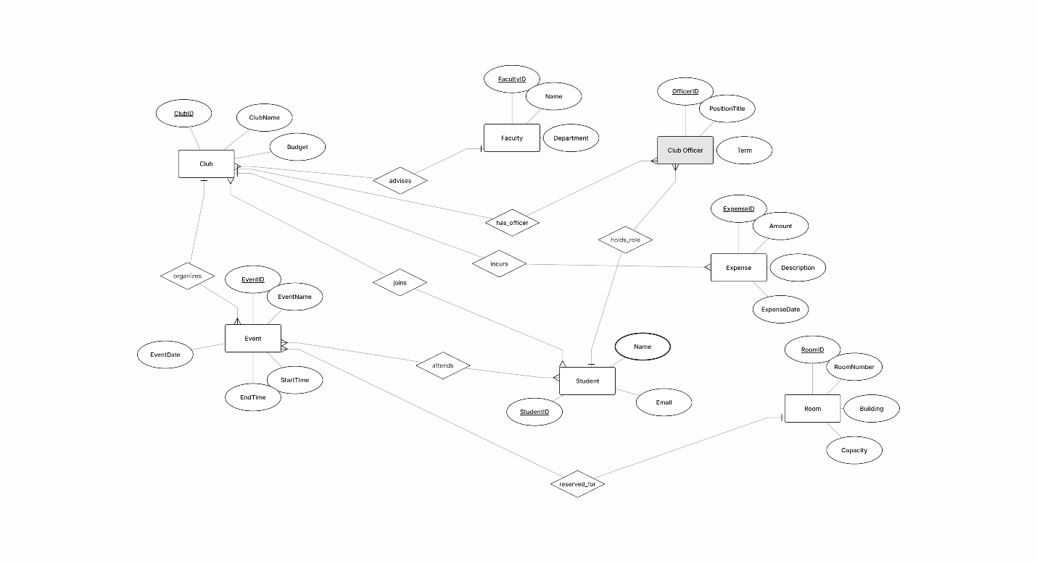

anel

